BIT 4107 – Mobile Application Development
ENHANCED PROFESSIONAL STUDENT LOGBOOK
Student Name: NOELLE BLESSING
Admission Number: BIT/2024/73309
School/Faculty: SCHOOL OF COMPUTING AND INFORMATICS
Programme: MOBILE APPLICATION AND DEVELOPMENT
Academic Year: YEAR 3
Semester: SEMESTER TWO
Lecturer: MICHAEL NYORO
Phone Number: 0703358067

Instructions
This logbook is used to document weekly learning activities, practical exercises, skills acquired, challenges encountered, solutions applied, and reflections. Students should complete all sections every week.
Each week to follow remarks in week 1 section.

Week 1: Introduction to Mobile Application Development

Practical Activities Undertaken
Figure 1: VS Code open showing Welcome screen and GitHub Copilot panel
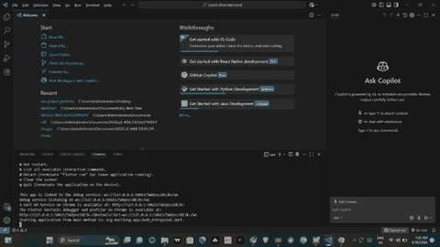

Figure 2: Flutter SDK folder structure in File Explorer
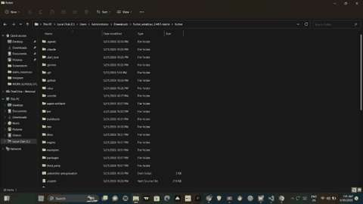

Figure 3: Flutter doctor showing green ticks — Flutter, Android toolchain, Chrome and Connected devices all working
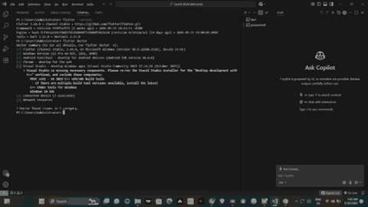

Figure 4: Default Flutter app running on Chrome — showing counter button functionality
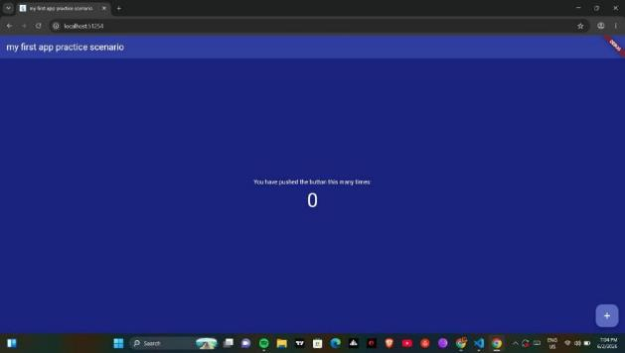
Figure 5: App title changed to ‘my first app practice scenario’ — visible in browser tab and app header
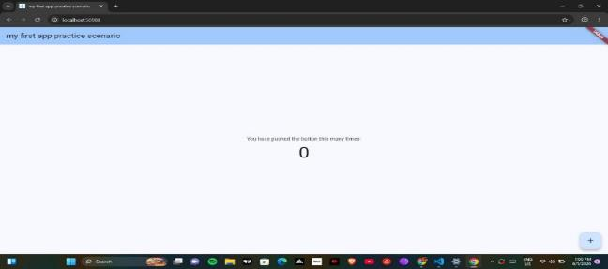

Figure 6: Background color changed to blue
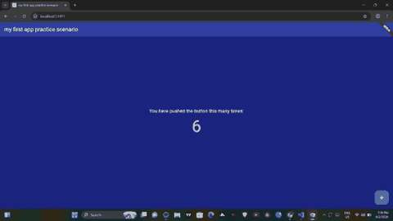
Screenshots/Evidence Attached: Yes

Tools/Software Used
Visual Studio Code (VS Code), Flutter SDK v3.44.0 (Dart), Android SDK v34.0.0, Git, Node.js, Python, GitHub Copilot, Chrome Browser (as emulator)

Personal Reflection
Week 1 involved setting up the full mobile development environment using VS Code and Flutter SDK. Despite PATH configuration challenges with Flutter and Android SDK, all tools were successfully installed. A first Flutter app was created, run on Chrome, and customized with a new title, background color, and font size.

Week 2: Mobile Development Environment

Practical Activities Undertaken
Figure 1: Login screen showing form validation errors on empty submission
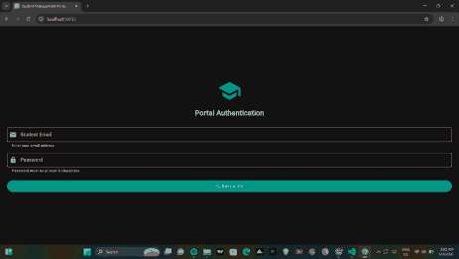
Figure 2: Student Registry screen showing empty state before any records are added
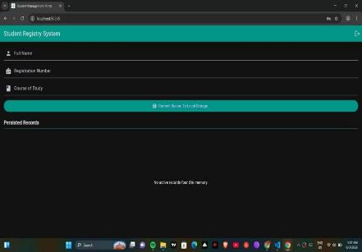
Figure 3: Student record saved — showing NOELLE, INFORMATION TECHNOLOGY | BIT/2024/73309
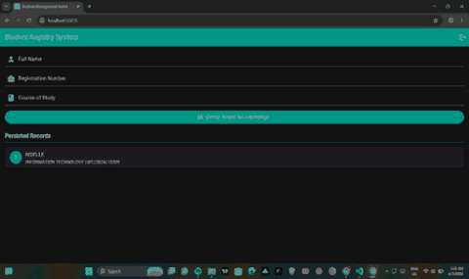

Screenshots/Evidence Attached: Yes

Tools/Software Used
Visual Studio Code (VS Code), Flutter SDK (Dart), Chrome Browser (as emulator)

Personal Reflection
Week 2 involved building a Mini Student Management App with login, form validation, multi-screen navigation, and in-memory record storage using Flutter. Challenges with state management and form validation were resolved using StatefulWidget and GlobalKey. The dark teal theme gave the app a professional finish.

Week 3: User Interface Design

Practical Activities Undertaken

Figma Wireframe — Screen 1: Authentication / Login
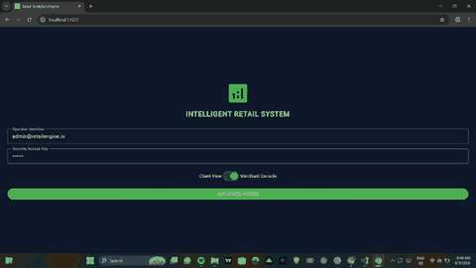

Figma Wireframe — Screen 2: Live Market Cata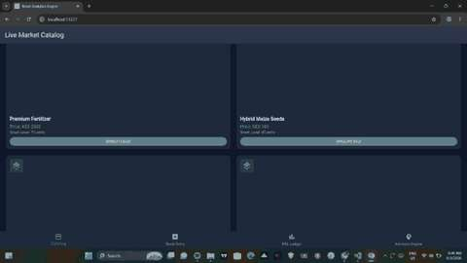

Figma Wireframe — Screen 3: Inventory Input Control
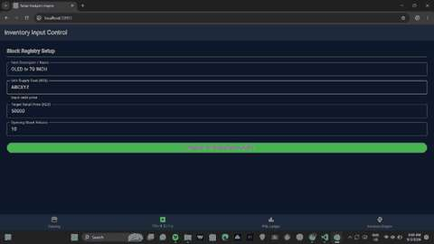
Figma Wireframe — Screen 4: Real-Time P&L Dashboard
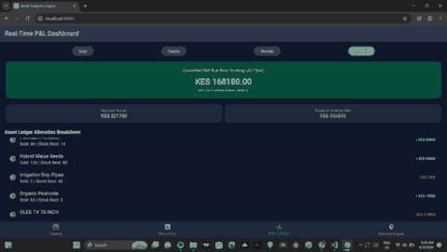
Figma Wireframe — Screen 5: Intelligent Optimization Advisory
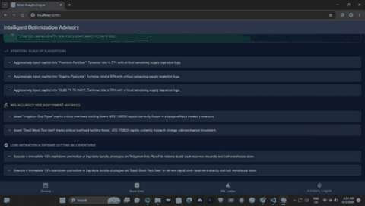

Real Device Test — Screen 1: Authentication (Android)

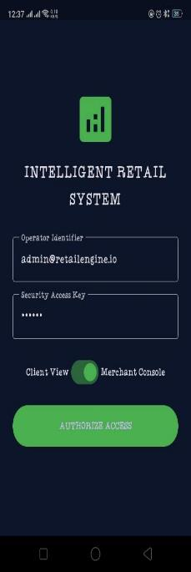

Real Device Test — Screen 2: Live Market Catalog (Android)

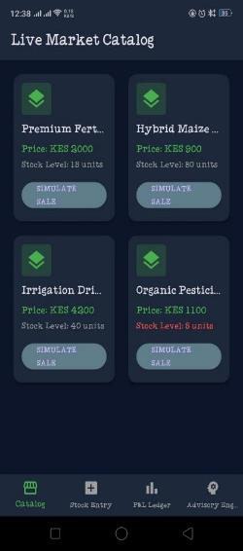

Real Device Test — Screen 3: P&L Dashboard (Android)

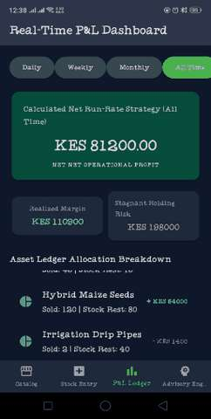

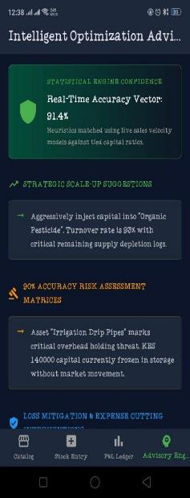

Real Device Test — Screen 4: Intelligent Advisory Engine (Android)
Screenshots/Evidence Attached: Yes

Tools/Software Used
Visual Studio Code (VS Code), Flutter SDK (Dart), Figma (UI wireframing), Android device (real device testing via USB debugging), Chrome Browser

Personal Reflection
Week 3 involved building a full 5-screen Intelligent Retail Analytics Engine addressing real business needs in Thika, Kenya. Key concepts covered included responsive GridView layouts, bottom navigation, global state management, Dart getters for profit/loss calculations, and deploying to a real Android device for testing.

Week 4: Data Management

Week 4: Data Management

Practical Activities Undertaken

The Week 4 practical focused on data management in the Intelligent Retail Analytics Engine Flutter application. Three major deliverables were implemented:

- Local data persistence using SQLite via the sqflite Flutter package
- Web platform compatibility using the Sembast NoSQL database
- A real-time Profit and Loss (P&L) Dashboard powered by database queries

SQLite Database Implementation

SQLite was integrated using the sqflite package to provide persistent local storage on Android. The database follows a full CRUD model:

Field | Type | Description
id | INTEGER | Auto-incremented primary key
name | TEXT | Product name
category | TEXT | Product category (e.g., electronics)
price | REAL | Selling price in KES
margin | REAL | Profit margin percentage
quantity | INTEGER | Number of units in stock
sold | INTEGER | Number of units sold

Sembast Web Support

Since sqflite does not support Flutter Web, Sembast was integrated for browser compatibility. The app uses platform detection (kIsWeb) to automatically switch between sqflite on Android and Sembast on Web — allowing a single codebase to run on both platforms.

Package | Purpose
sqflite | SQLite database for Android/iOS platforms
sembast | NoSQL store for cross-platform data persistence
sembast_web | Web-specific Sembast implementation for browser support
path_provider | Provides platform-specific paths for database file storage

Evidence / Screenshots

Figure 1: Stock Entry Screen showing saved product records (Laptop, TV, Samsung Tablet) with SQLite database confirmation message

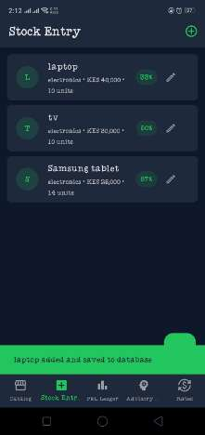

Figure 2: Real-Time P&L Dashboard showing computed metrics — 31.4% realized margin, KES 200,000 stagnant risk, best product Samsung Tablet at 67% margin

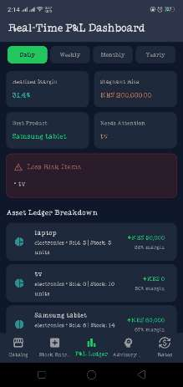

Figure 3: Live Market Catalog Screen displaying products retrieved from the SQLite
database in grid layout

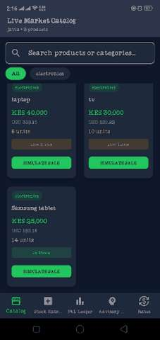

Screenshots/Evidence Attached: Yes

Tools/Software Used
Visual Studio Code (VS Code), Flutter SDK (Dart), sqflite package, sembast package, sembast_web package, Android device (real device testing), Chrome Browser (web testing)

Personal Reflection
Week 4 involved implementing full data management in the Intelligent Retail Analytics Engine. SQLite was integrated for Android using the sqflite package and Sembast was added for web platform support. All four CRUD operations were implemented and verified through the running application. The real-time P&L Dashboard reads directly from the database to compute profit, margin, and inventory metrics. The cross-platform database architecture ensures the app works seamlessly on both Android and browser environments without code changes.

Week 5: Networking and APIs

Practical Activities Undertaken

The Week 5 practical extended the Intelligent Retail Analytics Engine with live internet connectivity through REST API integration. Two external APIs were integrated:

- Open Exchange Rates API — live foreign exchange rates for KES/USD conversion
- World Bank API — Kenya macroeconomic data including inflation rate and GDP growth

APIs Integrated

Detail | Open Exchange Rates API
Endpoint | https://openexchangerates.org/api/latest.json
Response Format | JSON
Key Rate Fetched | KES — Kenyan Shilling (1 USD = 129.35 KES)
Used In | Catalog screen (KES→USD conversion), Rates screen (live rate display)

Detail | World Bank API
Country Code | KE (Kenya)
Indicators Fetched | Inflation rate (FP.CPI.TOTL.ZG), GDP growth (NY.GDP.MKTP.KD.ZG)
Values Retrieved | Inflation: 4.5% | GDP Growth: 4.7%
Used In | P&L Dashboard — Kenya Economic Context section and Advisory Engine

Implementation Details

- The http Flutter package was used to make GET requests to both APIs
- Responses received as JSON strings and decoded using Dart’s dart:convert library
- KES/USD formula: USD Price = KES Price ÷ KES Rate (e.g. KES 40,000 ÷ 129.35 = USD 309.24)
- World Bank data compared against business profit margin to auto-generate advisory messages
- Offline fallback rates implemented — app continues working without internet

Evidence / Screenshots

Figure 1: Exchange Rates screen showing live rates from Open Exchange Rates API — EUR (0.8624), GBP (0.7454), KES (129.35), USD (1.0000)

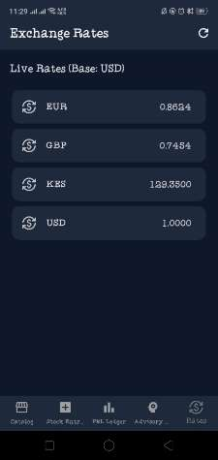

Figure 2: Live Market Catalog showing dual pricing — KES price in green and live USD conversion in blue on every product card
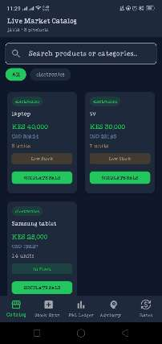

Figure 3: P&L Dashboard showing Kenya Economic Context section — inflation 4.5%, GDP growth 4.7%, margin beats inflation by 27.3%

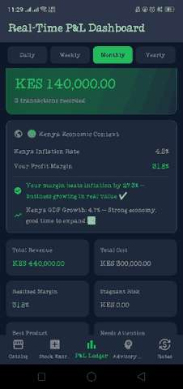

Figure 4: Advisory Engine showing Kenya Market Intelligence card with live economic advice generated from World Bank data

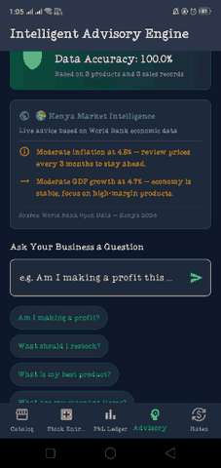

Screenshots/Evidence Attached: Yes

Tools/Software Used
Visual Studio Code (VS Code), Flutter SDK (Dart), http package, dart:convert library, Open Exchange Rates API, World Bank Open Data API, Android device (real device testing), Chrome Browser

Personal Reflection
Week 5 involved integrating two live REST APIs into the Intelligent Retail Analytics Engine, transforming it from a local database tool into a fully networked retail intelligence platform. The Open Exchange Rates API enables real-time KES to USD price conversion on every product card and a dedicated Rates screen. The World Bank API enriches the P&L Dashboard with Kenya macroeconomic context, automatically comparing business margins against national inflation and GDP data to generate actionable business advice. All Week 5 learning outcomes were achieved: REST APIs were consumed using the http package, JSON responses were parsed and displayed in the UI, and error handling was implemented for network failures.

Week 6: Networking Aspects in Mobile Application Development
Class Tasks Report

Task 1: Mobile Application Networking Analysis

The table below identifies the client, server, and data exchanged for five widely used mobile applications.

Application | Client | Server | Data Exchanged
WhatsApp | WhatsApp mobile app on the user’s phone | WhatsApp/Meta messaging servers | Text messages, voice notes, images, videos, read receipts, and online/typing status
Facebook | Facebook mobile app | Facebook/Meta social graph and content servers | Posts, comments, likes, photos, friend requests, and news feed content
Uber | Uber rider and driver apps | Uber dispatch and mapping servers | GPS location of rider and driver, trip requests, fare calculations, and route data
M-Pesa | M-Pesa app / SIM-based USSD menu | Safaricom mobile money servers | Account balance, transaction PIN, send/withdraw requests, and transaction confirmations
YouTube | YouTube mobile app | Google/YouTube video streaming and recommendation servers | Video streams, search queries, watch history, comments, and likes/subscriptions
Task 2: API Investigation Report

API Name
OpenWeatherMap API
Purpose
The OpenWeatherMap API provides current weather data, forecasts, and historical weather information for any location worldwide. It allows mobile and web applications to request real-time weather conditions such as temperature, humidity, wind speed, and general weather descriptions by simply specifying a city name or geographic coordinates.
GET Request Example
GET https://api.openweathermap.org/data/2.5/weather?q=Nairobi&appid=YOUR_API_KEY&units=metric

This request asks the server for the current weather conditions in Nairobi, returning the temperature in metric units (Celsius).
Expected Response (JSON)
{
"name": "Nairobi",
"main": {
"temp": 22.5,
"humidity": 60
},
"weather": [{ "description": "scattered clouds" }],
"wind": { "speed": 3.6 }
}

The server responds with a JSON object containing the location name, temperature, humidity percentage, a short weather description, and wind speed, all of which a mobile app would parse and display to the user.
Task 3: JSON Creation — Student Information

JSON data representing a student record, including registration number, name, course, and year of study.

{
"regno": "BIT/2024/73309",
"name": "Noelle Blessing",
"course": "Information Technology",
"year": "3"
}

This JSON structure follows the standard key-value pair format, making it lightweight, human-readable, and easy for a mobile application to parse and send to or receive from a server via API.

Week 7: Data Storage and Database Integration
Class Tasks Report

Task 1: Storage Method Comparison
Storage Method | Advantages | Disadvantages
Shared Preferences | Very simple to implement; ideal for small key-value data such as settings, currency, and business name; fast read/write | Cannot store structured or relational data; not suitable for large datasets; no querying capability
SQLite | Supports structured relational data with tables and relationships; supports complex queries (SQL); works fully offline; no server required | Slightly more setup complexity than Shared Preferences; data stored only on the local device unless synced; manual schema migration needed
Firebase | Cloud-based and accessible from multiple devices; real-time sync; built-in authentication; scalable for larger user bases | Requires internet connection; can incur cost at scale; less control over data structure compared to a relational database
Internal Storage | Good for storing files such as images, PDFs, or generated reports; private to the application | Not suitable for structured/queryable data; managing many files becomes difficult; no built-in search capability

Task 2: Student Database Design
The table below shows the design for a university student management application database.

Field | Data Type | Constraint | Description
StudentID | INTEGER | PRIMARY KEY, AUTOINCREMENT | Unique identifier for each student record
Name | TEXT | NOT NULL | Full name of the student
Course | TEXT | NOT NULL | Programme the student is enrolled in
Year | INTEGER | NOT NULL | Current year of study (1–4)
PhoneNumber | TEXT | UNIQUE | Student's contact phone number

Primary Key
StudentID is selected as the primary key because it uniquely identifies every student record and never changes, even if the student's name, course, or phone number is updated. Using an auto-incrementing integer also makes lookups and joins with other tables (such as an Attendance table) fast and efficient.

Task 3: Mini Project — Continuation of the Intelligent Retail Analytics Engine
As instructed, this task continues directly from the mobile application already being developed across the previous weeks — the Intelligent Retail Analytics Engine, a universal retail management app for small businesses. Rather than building a separate attendance application, the same persistent storage and security concepts taught in Week 7 (registration, authentication, hashing, and structured local storage) have been applied directly to the existing project.

Storage Method Selected
SQLite was selected as the primary storage method for the application, supplemented by Shared Preferences for simple settings such as currency and business name.

Why SQLite Was Selected
- The application needs to store structured, relational data — products, sales transactions, and user accounts — which Shared Preferences cannot handle.
- SQLite works fully offline, which is essential for small retail businesses in areas with unreliable internet connectivity, such as Thika CBD.
- SQLite allows fast querying of sales history to calculate real-time profit and loss figures.
- No external server or ongoing cost is required, unlike Firebase, making it sustainable for a small business owner to use long-term.

Database Structure
The application uses three core tables in its SQLite database:

Table: users

Field | Data Type | Constraint | Description
id | TEXT | PRIMARY KEY | Unique identifier for each registered operator
fullName | TEXT | NOT NULL | Full name of the operator
email | TEXT | UNIQUE, NOT NULL | Operator identifier used to log in
passwordHash | TEXT | NOT NULL | SHA-256 hashed password — the plain password is never stored
role | TEXT | NOT NULL | Access role: Merchant Console or Client View

Table: products

Field | Data Type | Constraint | Description
id | TEXT | PRIMARY KEY | Unique identifier for each product
name | TEXT | NOT NULL | Product name
category | TEXT | NOT NULL | Product category (e.g. Electronics, Food)
costPrice / sellingPrice | REAL | NOT NULL | Used to calculate profit margin automatically
stockQty | INTEGER | NOT NULL | Current stock level

Table: sales

Field | Data Type | Constraint | Description
id | TEXT | PRIMARY KEY | Unique identifier for each sale transaction
productId | TEXT | FOREIGN KEY → products.id | Links each sale to the product sold
quantitySold | INTEGER | NOT NULL | Number of units sold in this transaction
totalRevenue / profit | REAL | NOT NULL | Calculated automatically at the time of sale

Relationships
The sales table relates to the products table through a one-to-many relationship: one product can have many sale records, linked via the productId foreign key. This allows the application to calculate total revenue, total profit, and turnover rate per product by querying the sales table.

Normalization
The database follows Third Normal Form (3NF) principles. Product details (name, category, prices) are stored once in the products table rather than being repeated on every sale record. The sales table only stores a reference (productId) plus transaction-specific data, eliminating data redundancy and ensuring that updating a product's price does not require updating historical sales records.

Password Hashing Evidence
To protect operator credentials, the application hashes every password using the SHA-256 algorithm before it is stored or compared. The plain-text password is never saved in the database — only its irreversible hash is stored in the passwordHash column of the users table.

String hashPassword(String password) { final bytes = utf8.encode(password); final digest = sha256.convert(bytes); return digest.toString(); }

During login, the password entered by the user is hashed using the same function and compared against the stored hash in the database. If they match, access is granted; if not, an "Invalid security access key credentials" message is shown.

Figure 1: Register Operator Screen
The Register Operator screen captures Full Name, Operator Identifier (Email), System Access Role (Merchant Console or Client View), and Security Access Key (Password) with a confirmation field. This screen writes a new record to the users table via the insertUser() method, which rejects duplicate emails.

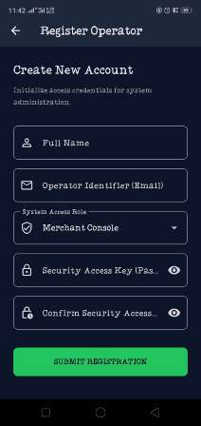
Figure 1: Register Operator screen — capturing Full Name, Operator Identifier (Email), System Access Role, and Security Access Key (Password) with confirmation field

Figure 2: Login Screen — Live SHA-256 Hash Generation
The Login screen shown below demonstrates the SHA-256 hash being generated in real time as the password is typed for the operator account lionoble20@gmail.com under the Merchant Console access mode. The generated hash (ef797c8118f02dfb649607dd5d3f8c7623048c9c063d532cc95c5ed7a898a64f) confirms the hashing mechanism is functioning correctly before the credential is ever sent for comparison against the stored hash in the database.

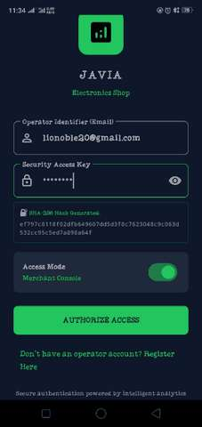
Figure 2: Login screen showing the SHA-256 hash generated in real time as the password is typed, confirming the hashing mechanism is functioning correctly before the credential is ever sent for comparison

Additional Evidence — Products and Sales Data Persistence
The following two screenshots provide direct evidence that the products and sales tables described above are not only structurally defined but actively storing and retrieving real data within the running application, as the logged-in operator "Noelle" under the Merchant Console role.

Figure 3: Live Market Catalog — Products Table in Action
This screenshot shows the Catalog screen reading directly from the products table. Three real product records are displayed — Laptop (KES 40,000, 5 units, Low Stock), TV (KES 30,000, 7 units, Low Stock), and Samsung Tablet (KES 25,000, 14 units, In Stock) — each with a live USD conversion. This confirms the products table is correctly storing structured data (name, category, costPrice/sellingPrice, stockQty) and that the application successfully queries and renders it.

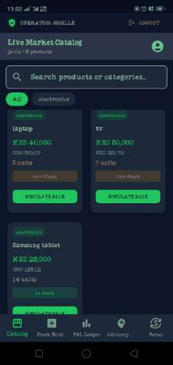
Figure 3: Live Market Catalog screen displaying real product records retrieved from the SQLite products table, confirming successful structured data storage

Figure 4: Real-Time P&L Dashboard — Sales Table in Action
This screenshot shows the P&L Dashboard computing real business metrics directly from the sales table. Monthly Total Revenue of KES 440,000.00 against Total Cost of KES 300,000.00 yields a Realized Margin of 31.8%. The dashboard also demonstrates the foreign key relationship between sales and products by identifying the Best Product (Samsung Tablet) and the product Needing Attention (TV) — both derived by joining sales records back to their corresponding products via the productId foreign key, exactly as described in the Relationships section above.

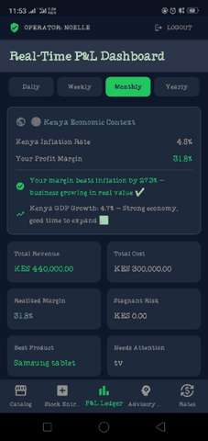
Figure 4: Real-Time P&L Dashboard showing computed revenue, cost, and margin figures derived from real records in the sales table, confirming the products-sales relationship is functioning correctly

Expected Outputs
- A new operator can register with a hashed password stored securely in the users table.
- Returning operators log in using their email and password, which is hashed and matched against the stored hash — plain passwords are never compared or stored.
- Role-based access ensures a Merchant Console user and a Client View user are not interchangeable, even with the same credentials.
- All product and sales data persists in SQLite, surviving app restarts, and feeds directly into the Real-Time P&L Dashboard and Intelligent Advisory Engine built in previous weeks.

Weekly Practical Logbook — Week 8
Handling User Input and Events Using OOP (Keyboard Input & Touch Gestures)
Project: Retail Analytics Engine
Business: Jivu Limited (Electronics Shop)
- Weekly Objective

This week's practical task required developing a class-based (OOP) system within the mobile application that:
- Accepts and processes keyboard input
- Detects and responds to touch gestures (tap, long-press, swipe)
- Logs user interaction events with timestamps
- Displays appropriate messages/feedback when interactions occur
- Organizes all functionality into separate, reusable classes and methods

Per the continuous-project structure of this course, this week's work was implemented as an extension of my ongoing individual project — the Retail Analytics Engine — rather than as a standalone generic demo. All four new service classes were wired directly into existing, real screens of the app (Login, Register, Catalog, and Stock Entry).

2. System Overview
The Retail Analytics Engine is a Flutter application (running on both Android and web from one codebase) built for a fictional electronics retail business, 'Jivu Limited'. It supports inventory tracking, sales recording, profit/loss analytics, live currency rates, user accounts, and M-Pesa mobile payments via the IntaSend sandbox API.
Relevant existing screens used for this week's implementation:
- Auth Screen (Login) — email/password, SHA-256 hashed, validated against the users table
- Register Screen — creates new operator accounts
- Catalog Screen — product grid with search, tap-to-sell, and long-press quick view
- Stock Entry / Inventory Form — add, edit, and swipe-to-delete products

3. New Class-Based Components Added
Four new service classes were created under lib/services/, plus one new screen for log viewing:
File | Purpose
validator_service.dart | Centralized input validation — email, password, product name, price, stock quantity
event_logger_service.dart | Records every keyboard, gesture, login, register, and validation event with a timestamp, in-memory
input_handler_service.dart | Wraps keyboard-driven submit actions (login, register, search, stock entry) with validation + logging
gesture_service.dart | Wraps touch gesture callbacks (tap, long-press, swipe, double-tap) with logging
logs_screen.dart | New in-app screen that displays all logged events, filterable by type, for live demonstration without USB debugging

4. Activity 1 — Centralized Input Validation
A ValidatorService class was created to centralize all form validation logic that was previously scattered as inline validator functions across screens. This makes validation rules reusable and consistent across the Register, Login, and Stock Entry forms.

Code Snippet
class ValidatorService {
static String? validateEmail(String email) {
if (email.trim().isEmpty) return 'Email cannot be empty';
final emailRegex = RegExp(r'^[\w.+-]+@[\w-]+\.[a-zA-Z]{2,}$');
if (!emailRegex.hasMatch(email.trim())) {
return 'Enter a valid email address';
}
return null;
}

static String? validatePassword(String password) {
if (password.length < 6) return 'Password must be at least 6 characters';
return null;
}
// ...validateProductName, validatePrice, validateStockQuantity, etc.
}

Testing Evidence
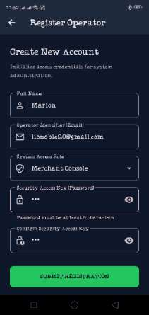  Register: password under 6 characters | Test: Weak password on Register  Entered a password shorter than 6 characters on the Register screen.  ValidatorService.validatePassword() rejected it and the form displayed: 'Password must be at least 6 characters'.

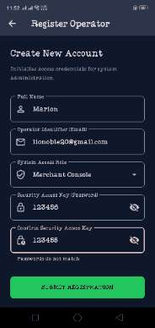  Register: passwords do not match | Test: Mismatched confirm-password  Entered '123456' and '123455' as password and confirm-password.  ValidatorService.validatePasswordMatch() caught the mismatch and displayed: 'Passwords do not match'.

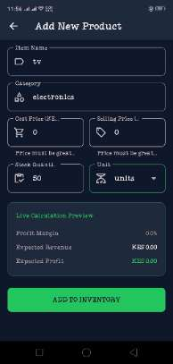  Stock Entry: price = 0 rejected | Test: Invalid product price on Stock Entry  Attempted to add a product ('tv') with cost and selling price left at 0.  ValidatorService.validatePrice() blocked submission with: 'Price must be greater than zero' on both fields.

5. Activity 2 — Event Logging
An EventLoggerService class records every keyboard, gesture, login, register, sale, and validation event with a timestamp, stored in-memory as a list of AppEvent objects. A companion LogsScreen was added so events can be viewed directly inside the app, filterable by event type — this avoids relying on USB debugging / terminal output to demonstrate evidence on a real device.

Code Snippet
class EventLoggerService {
static final List<AppEvent> _events = [];

static void log(String type, String details) {
final event = AppEvent(type: type, details: details);
_events.add(event);
print(event.toString());
}

static void logKeyboardEvent(String details) => log('KEYBOARD', details);
static void logGestureEvent(String details) => log('GESTURE', details);
static void logValidationEvent(String details) => log('VALIDATION', details);
static void logLoginEvent(String details) => log('LOGIN', details);

static List<AppEvent> getEvents() => _events.reversed.toList();
static List<AppEvent> getEventsByType(String type) =>
_events.where((e) => e.type == type).toList().reversed.toList();
}

Testing Evidence
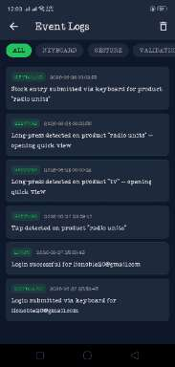  Event Logs screen — all events | Test: In-app Logs screen (ALL filter)  Opened the new Logs screen from the Catalog AppBar (receipt icon).  Confirmed real, timestamped events for KEYBOARD, GESTURE and LOGIN types were captured live as the app was used, e.g. 'Long-press detected on product "radio units"' and 'Login successful for lionoble20@gmail.com'.

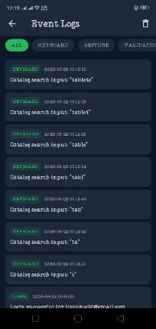  Event Logs — keyboard search progression | Test: Logs screen reflecting live typing  While typing 't', 'ta', 'tab', 'tabl', 'table', 'tablet', 'tablets' into the Catalog search bar, each individual keystroke produced its own timestamped KEYBOARD log entry.  Confirms the keyboard handler is firing per character, not just on submit.

6. Activity 3 — Keyboard Input Handling
An InputHandlerService class wraps keyboard-driven submit actions (login, register, catalog search, stock entry) so that validation and logging happen consistently before the underlying business logic runs.

Code Snippet
static void handleLoginSubmit({
required String email,
required String password,
required void Function() onValid,
required void Function(Map<String, String> errors) onInvalid,
}) {
final errors = <String, String>{};
final emailError = ValidatorService.validateEmail(email);
if (emailError != null) errors['email'] = emailError;
final passwordError = ValidatorService.validatePassword(password);
if (passwordError != null) errors['password'] = passwordError;

if (errors.isNotEmpty) {
EventLoggerService.logValidationEvent('Login submit blocked — errors: $errors');
onInvalid(errors);
return;
}
EventLoggerService.logKeyboardEvent('Login submitted via keyboard for $email');
onValid();
}

Testing Evidence
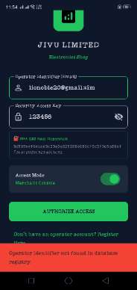  Login: operator identifier not found | Test: Login with unregistered email  Attempted login with an email not present in the users table.  InputHandlerService validated the format, passed it through, and the DB lookup correctly returned: 'Operator identifier not found in database registry.'

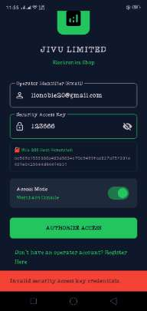  Login: invalid security access key | Test: Login with wrong password  Logged in with a valid registered email but an incorrect password.  System displayed: 'Invalid security access key credentials.' — confirming password-hash comparison still runs correctly after the new input-handling layer was added.

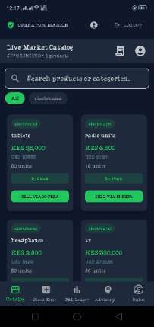  Login: successful authentication | Test: Login with correct credentials  Logged in with correct email/password as operator 'Marion'.  Successfully navigated into the main app (Live Market Catalog), confirming the full keyboard-submit → validate → log → authenticate chain works end-to-end.

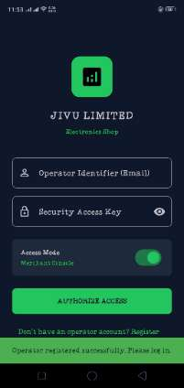  Register: successful submission | Test: Successful registration  After correcting the earlier validation errors (password length, confirm-password match), submitted valid registration details.  System displayed: 'Operator registered successfully. Please log in.' and returned to the Login screen.

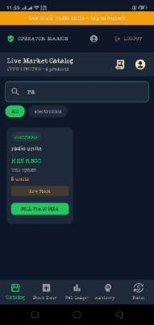  Catalog: live search filtering | Test: Catalog search-as-you-type  Typed 'ra' into the Catalog search bar.  InputHandlerService.handleCatalogSearchInput() logged the keystroke and the product grid live-filtered down to 'radio units' only.

  Stock Entry: valid product saved | Test: Successful stock entry submission  After correcting the price-validation error, submitted a valid product ('tv', KES 350,000, 50 units).  InputHandlerService.handleStockEntrySubmit() validated all fields, then the product was saved and the confirmation 'tv added and saved to database' appeared.

7. Activity 4 — Touch Gesture Detection
A GestureService class wraps tap, long-press, swipe, and double-tap callbacks on product cards, logging each interaction before triggering the existing UI behaviour (sale dialog, quick-view dialog, delete confirmation).

Code Snippet
class GestureService {
static void onProductTap({required String productName, required void Function() onAction}) {
EventLoggerService.logGestureEvent('Tap detected on product "$productName"');
onAction();
}

static void onProductLongPress({required String productName, required void Function() onAction}) {
EventLoggerService.logGestureEvent(
'Long-press detected on product "$productName" — opening quick view',
);
onAction();
}

static void onProductSwipe({
required String productName,
required String direction,
required void Function() onAction,
}) {
EventLoggerService.logGestureEvent(
'Swipe ($direction) detected on product "$productName"',
);
onAction();
}
}

Testing Evidence
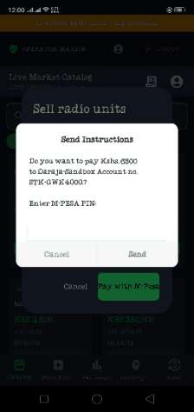  Tap gesture — Sell via M-Pesa | Test: Tap gesture on product card  Tapped 'SELL VIA M-PESA' on the 'radio units' product card.  GestureService.onProductTap() logged the tap, then the sale dialog opened and proceeded into the M-Pesa STK push prompt requesting the PIN.

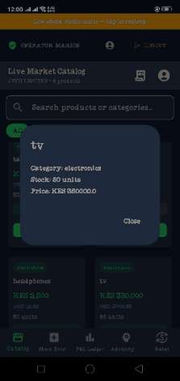  Long-press gesture — quick view | Test: Long-press gesture on product card  Long-pressed the 'tv' product card.  GestureService.onProductLongPress() logged the event and opened a quick-view dialog showing Category, Stock, and Price — without leaving the Catalog screen.

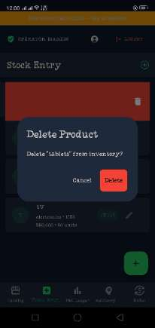  Swipe gesture — delete confirmation | Test: Swipe gesture on Stock Entry list item  Swiped the 'tablets' row left on the Stock Entry screen.  GestureService.onProductSwipe() logged the swipe direction, and the existing Dismissible widget showed the red delete background and a confirmation dialog.

8. Additional Testing — M-Pesa Payment on Real Device
As a secondary check, the tap-to-sell flow was tested through to the actual M-Pesa/IntaSend sandbox call on a physical Android device (rather than Chrome/web, where a CORS policy error had previously blocked the request entirely).
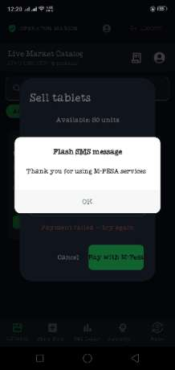  M-Pesa sandbox result on device | Test: Full M-Pesa payment attempt on physical device  On-device, the CORS error seen on web did not occur — the request reached the IntaSend sandbox successfully.  The sandbox returned a simulated 'Flash SMS message: Thank you for using M-PESA services' followed by a 'Payment failed — try again' status, which is expected sandbox behaviour rather than a code defect.  Confirms native apps are not subject to browser CORS restrictions, resolving the earlier web-only limitation noted in previous testing.

9. Challenges Faced and Solutions
Challenge | Solution
print() log output was not visible when running the app in a Chrome web tab. | Opened Chrome DevTools (F12) → Console tab, which streams Flutter web's debug print output; later replaced with USB-connected device logs and an in-app Logs screen.
Debug APK install failed on the physical device with INSTALL_FAILED_INSUFFICIENT_STORAGE. | Built a smaller --release APK instead and added a dedicated in-app LogsScreen so event-log evidence no longer depends on a live USB/terminal connection.
Uninstalling the debug build between tests wiped the local SQLite database (users, products, sales), as this is standard Android behaviour for app data on uninstall. | Re-ran the Setup Wizard and Register flow after reinstalling — this also provided fresh, clean evidence of the Register-screen validation working from scratch.
M-Pesa/IntaSend sandbox call was blocked by a browser CORS policy when testing on Flutter web. | Re-tested on a physical Android device via USB, where CORS (a browser-only restriction) does not apply, confirming the request reaches the sandbox successfully.

10. Reflection and Lessons Learnt
- Centralizing validation, logging, input handling, and gesture handling into separate service classes made the codebase noticeably cleaner — validation rules that were previously duplicated inline across three different forms are now defined once and reused.
- Gesture and keyboard-input behaviour is best verified through real device testing rather than browser emulation — long-press and swipe gestures behave more naturally with an actual finger than with a simulated mouse click-and-drag.
- Mobile app local storage (SQLite/Shared Preferences) is tied to the app's install — uninstalling the app deletes all local data, which is expected platform behaviour rather than an application bug.
- Adding an in-app event log viewer turned out to be a more robust form of evidence than relying solely on terminal/USB debugging output, since it works identically on any build type (debug or release) without extra tooling.
- Browser-based testing (Flutter web) has real limitations — such as CORS restrictions on third-party payment APIs — that do not apply once the same code runs as a native Android app.

11. Conclusion
All Week 8 requirements were implemented and verified directly within the Retail Analytics Engine project:
keyboard input handling (login, register, search, stock entry), touch gesture detection (tap, long-press, swipe), event logging with timestamps, and clear on-screen messaging for every interaction.
Functionality was organized into five separate, reusable classes (ValidatorService, EventLoggerService, InputHandlerService, GestureService, and the LogsScreen UI), satisfying the OOP / class-based structure required by the brief.
All evidence above was captured from real interactions on a physical Android device running the application.

Week 9: Device Features and Sensors

Same as week 1

Week 10: Notifications and Background Services

Same as week 1

Week 11: Mobile Security

Same as week 1

Week 12: Testing and Debugging

Same as week 1

Week 13: Application Deployment

Same as week 1

Week 14: Final Project Presentation

Same as week 1

Semester Project Tracking

Project Title

Project Objectives

Project Requirements

Development Milestones

Testing Results

Lessons Learned

Future Improvements

End of Semester Reflection

Summary of Skills Acquired

Most Interesting Topic

Major Challenges Faced

How Challenges Were Overcome

Professional Growth Achieved

Overall Course Experience

Final Approval
Student Name: __________________________
Student Signature: ______________________
Date: _________________________________
Lecturer Name: _________________________
Lecturer Remarks: _____________________
Date: _________________________________

